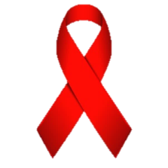
Healing Our Nations
Presents
A
2nd Annual
boriginal

Family Fun Day
IDS
warness
Indian Tacos Games
(1st 100 People Only)
Aboriginal Vendors
Photo Booth Bingo Spray Tattoos
Where: Shubie Community Centre, Indianbrook
When: Dec 1st, 2015 4pm-8pm
Who: Everyone!
40” Flat Screen TV Door Prize
FREE ADMISSION – FREE ADMISSION

